**Mrs Janet McDermott**

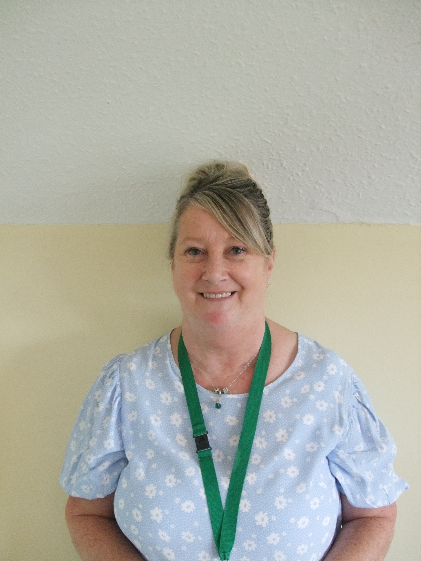

If you have any concerns and feel that you would benefit from support, please contact me.

0161 432 5785

janet.mcdermott@st-elisabeths.stockport.sch.uk

**The Responsibilities of a Child and Family Support Worker (CFSW)**

A CFSW is able to offer support, advice and guidance to our children and families.

Support for pupils includes:

* Promoting good attendance and punctuality
* Promoting self-esteem and confidence
* Promoting positive behaviour and positive attitudes to learning
* Providing personal, social and emotional support

Support for families includes:

* Advice and support in promoting positive behaviour at home
* Attendance and support at school and other agency meetings
* Liaising with a range of outside agencies
* Providing information about services available in the local area
* Organising and leading parent workshops

I will also attend any relevant training linked to my role.

**Background Information:**

I have been a member of the St Elisabeth’s Team for the past 20 years. During this time I have worked closely with children and families addressing a number of differing needs. I have led parent workshops and am trained in offering support for bereavement, anxiety, stress, mental health, relaxation therapy and behaviour.